# Manual Testing

Task 1:

Student enrollment requires two actions:

1. Search for a school

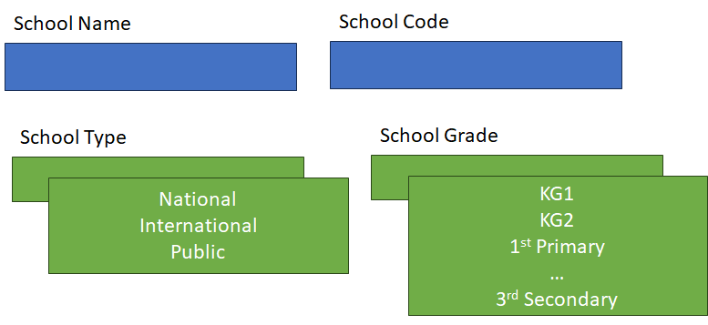

Blue boxes are text fields.

Green boxes are lists.

All fields are required.

Press Search once you fill in the data.

1. Fill in student’s information as follows:

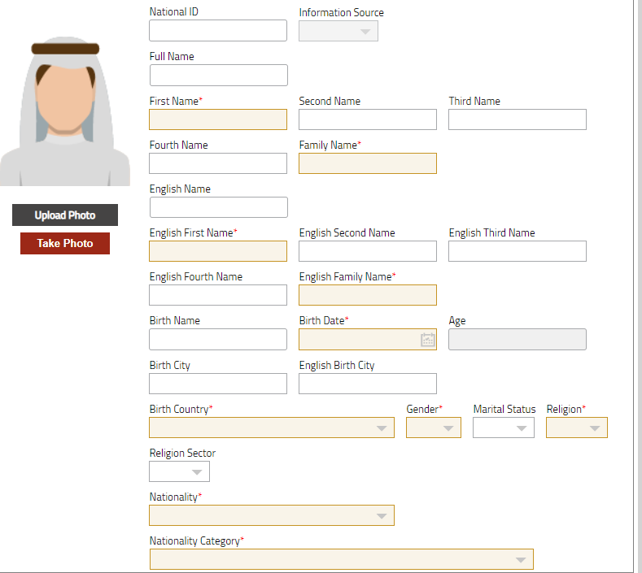

Required fields are highlighted in *

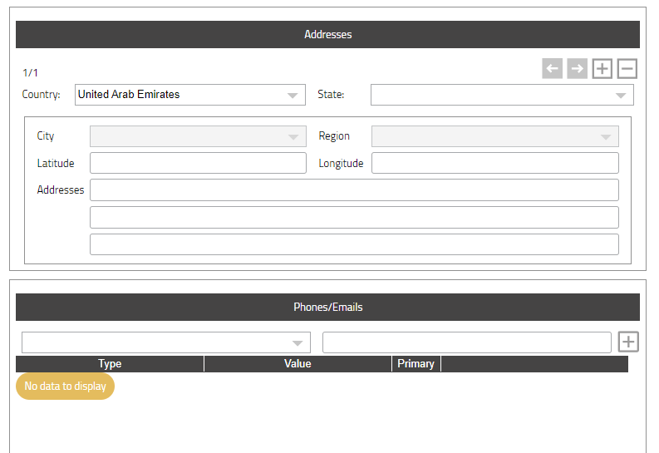

Address, Phones/Emails: You fill in the data and press + to add a new record. You may fill in records as much as you need.

Business Rules:

* Student national ID must not be repeated.
* You may enroll one student at a time.

Write all possible detailed test cases for the above scenario – full coverage with efficiency.

You may use any template or tool.

Bonus Task:

Generate test cases using AI powered generative tool.

Task 2:

The DB diagram shows the partial relationship and constraints.

Based on the diagram, review the data in the attached excel sheet and extract the valid data only.

School

Student

School ID (R,U)

School Name (R, U)

Gender (R)

Religion (R)

National ID (R,U)

English Name (English First Name, English Second Name, English Third Name, English Fourth Name, English Family Name) (R,U)

English First Name (R)

English Family Name (R)

Birth Country (R)

Nationality (R)

Gender (R)

Religion (R)

Nationality Category (R)

School ID (Ref, R)

Notes:

* National ID must start with 1234 and must be 10 digits
* If school gender doesn’t accept mixed, it student’s gender must match school gender.

# Code Assessment

1. An ATM program is developed to check card type as the ATM will accept payment with Master Cards only would you mention what is the best practice for this piece of code:

If(Card.Type == “Premium”)

Return False;

Else If(Card.Type == “Master”)

Accept Transaction;

Else if(Card.Type == “Youth”)

Return False;

Else

Return Error;

1. Find the error in the following piece of code:

int n = 0;

While( n<10)

{

int a =n+2;

int b =a+n;

System.out.println(“a = ”+a);

n=5;

}

System.out.println(“a = “+a);

System.out.println(“b = “+b);

System.out.println(“n = “+n);

**API Manual Testing**

You are given an API endpoint for a weather service that provides current weather information for a given city.

The API endpoint is GET /api/weather/{cityName}.

The task is to write at least 3 detailed test cases to verify the correctness of the API response.

# Automation Testing

## Web Automation

1. What are the different types of locators in Selenium?
2. What are the different types of Drivers available in WebDriver?
3. What are the different types of waits available in WebDriver?
4. What is the difference between driver.quite() and driver.close()?
5. An automation task is needed to simulate the creation of course scenarios at winjigo website.

Scenario Steps:

* 1. Open <https://swinji.azurewebsites.net> website.
  2. Sign in with username [testregister@aaa.com](mailto:testregister@aaa.com) and password “Wakram_123”.
  3. Open courses page from left side navigation bar.
  4. Click on create course button
  5. Fill course basic info then click save
  6. Back to courses list page and assert that course title is displayed.

Recommended Tools Cucumber, Selenium with Java, Maven and Junit or Selenium with C# and Nunit.

Inputs and Outputs values must not be hard codded in the script.

It will be added value in case the development of test scenario is written using page object model.

## API Automation

Given the following API <https://www.boredapi.com/api/activity>

The api business is providing a person with an activity to do in case he/she is feeling bored and the suggestion each time is random activity.

A sample of response is like the following:

{

"activity":"Teach your dog a new trick",

"type":"relaxation",

"participants":1,

"price":0.05,

"link":"",

"key":"1668223",

"accessibility":0.15

}

You are required to write an automation task to call the API and verify its response code and response schema using rest assured, cucumber and java.

## Mobile Automation

Download the teacher kit app and student kit app which are provided in the email and install them on your android device.

<https://install.appcenter.ms/orgs/itworx-education/apps/winjigo-teacher/distribution_groups/public>

Using Appium, cucumber, java and Maven automate the following scenario.

1. Open teacher kit app and Login with the following teacher credentials [Test.teacher@mailinator.com](mailto:Test.teacher@mailinator.com) and Pass: Abc_123
2. Select courses tab then click on course with name “Mobile Automation”.
3. Click on the behavior tab.
4. Select student with name “Test student”.
5. Click on the “take behavior” button.
6. Select behavior (Positive or Negative), select type, level, deselect the private behavior check box and add note then click save.
7. Assert success message appear.
8. Open student kit app and Login with the following student credentials [test.student@mailinator.com](mailto:test.student@mailinator.com) and Pass: Abc_123
9. Click on the three dots appear on the top of the dashboard then select behavior.
10. Assert that the previously added behavior by the teacher exists.